

COMPUTER NETWORKS

ASSIGNMENT # 1

QUIC Analysis

Submitted by: Izza Iqbal
Registration no: B23F0317AI119
Submitted to: Dr Adnan Iqbal
Department: BSAI Red
Date: 22nd Sep 2025

QUIC Website Analysis:
I have attach the file to capture QUIC, in which I did the following steps
Steps:
- Capturing QUIC Traffic
- Generating QUIC Traffic
- Analyzing QUIC Packets

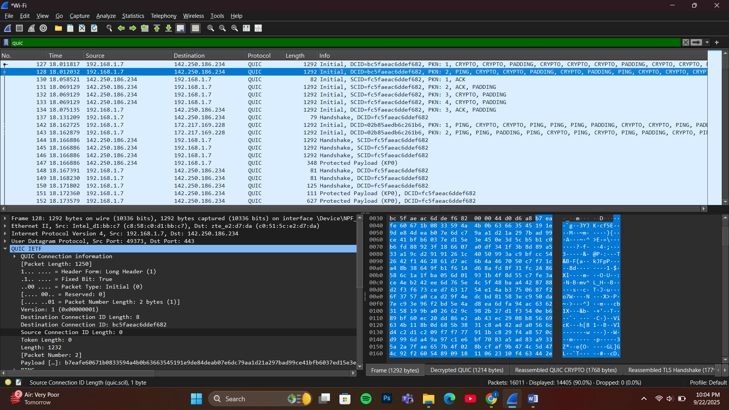

Questions:
- QUIC Website Name:
- Examine initial QUIC handshake packets
- The protocol column shows "QUIC"
- Using UDP port 443
- Multiple QUIC packet types visible (Initial, Handshake, Protected Payload)

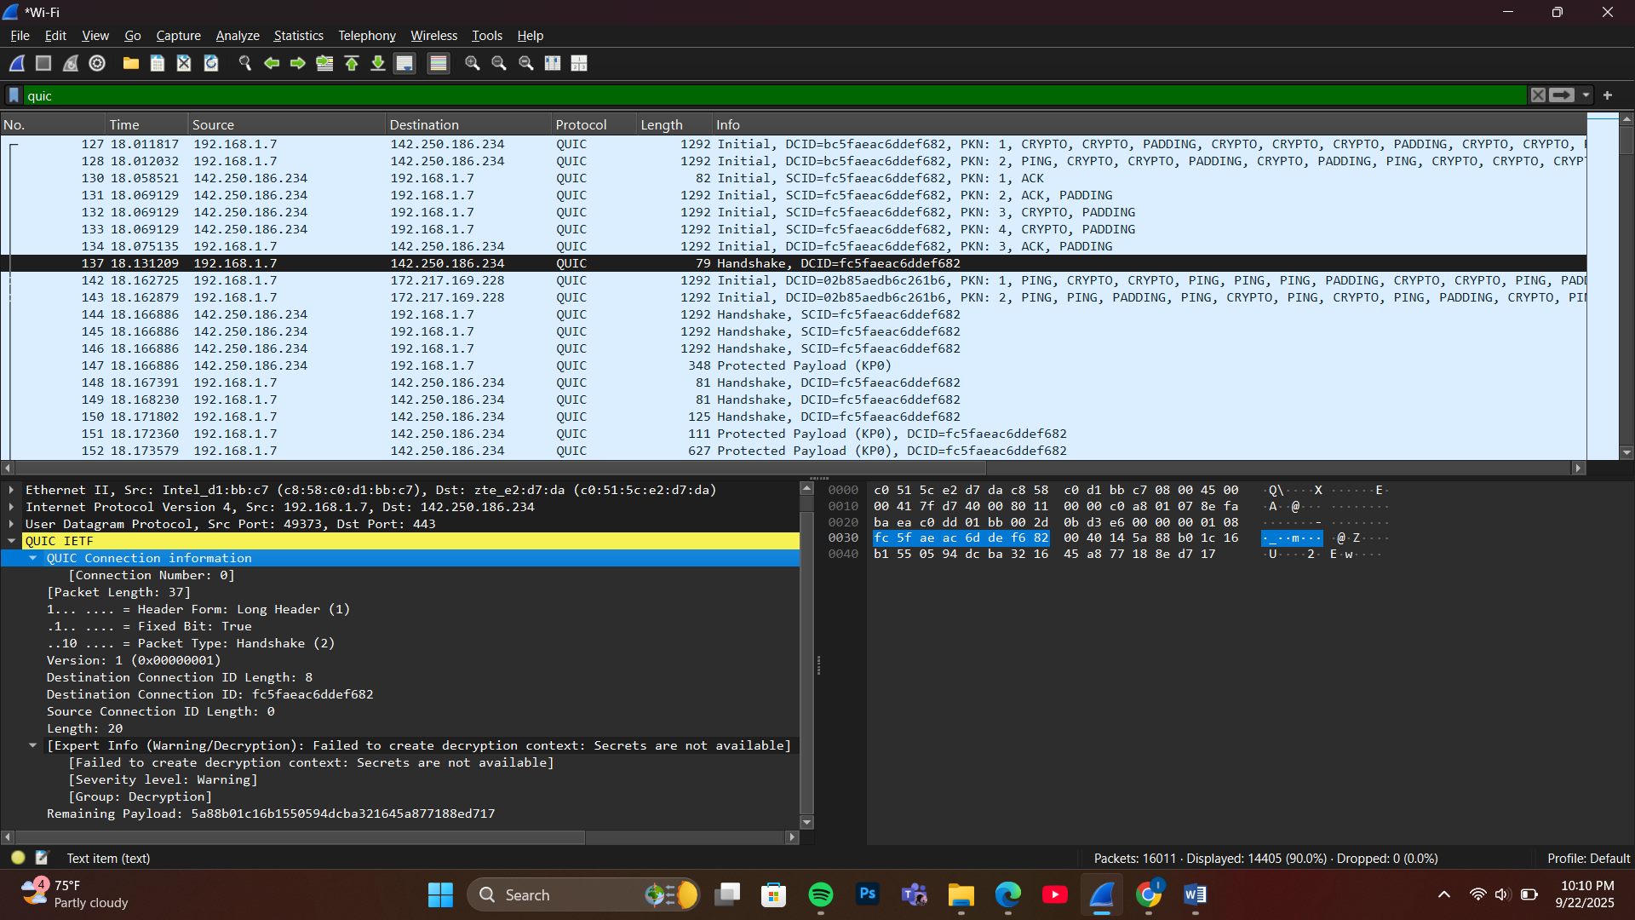

- Initial QUIC Handshake
• Find Initial packet: Look for QUIC packet with "Initial" packet type
• Extract information: Connection ID, version information

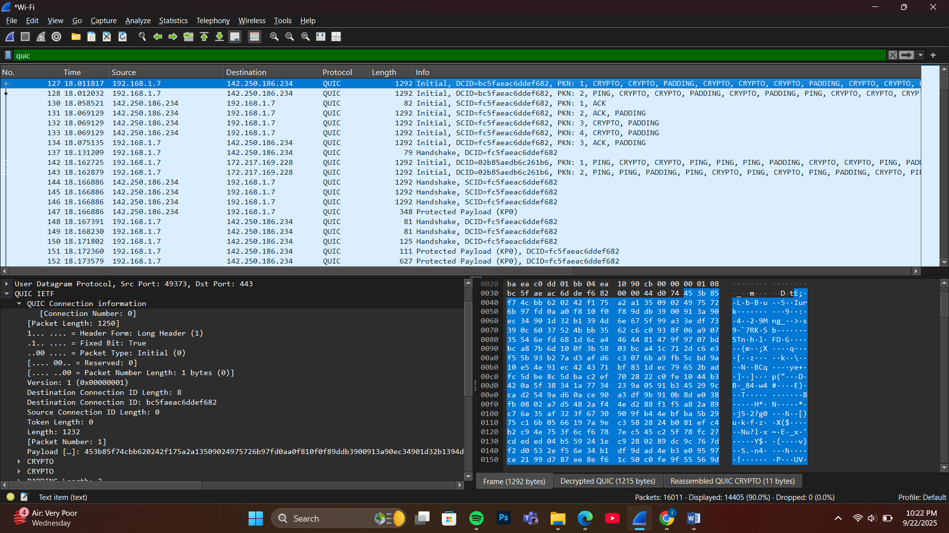

I have,
- Initial packets captured
- Connection ID extracted
- Version information
- QUIC protocol analysis

- TLS ClientHello in QUIC:
• Location: Inside QUIC Initial packet, find embedded TLS ClientHello
• Method: Expand packet details to find TLS handshake data

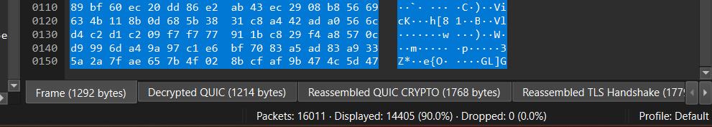

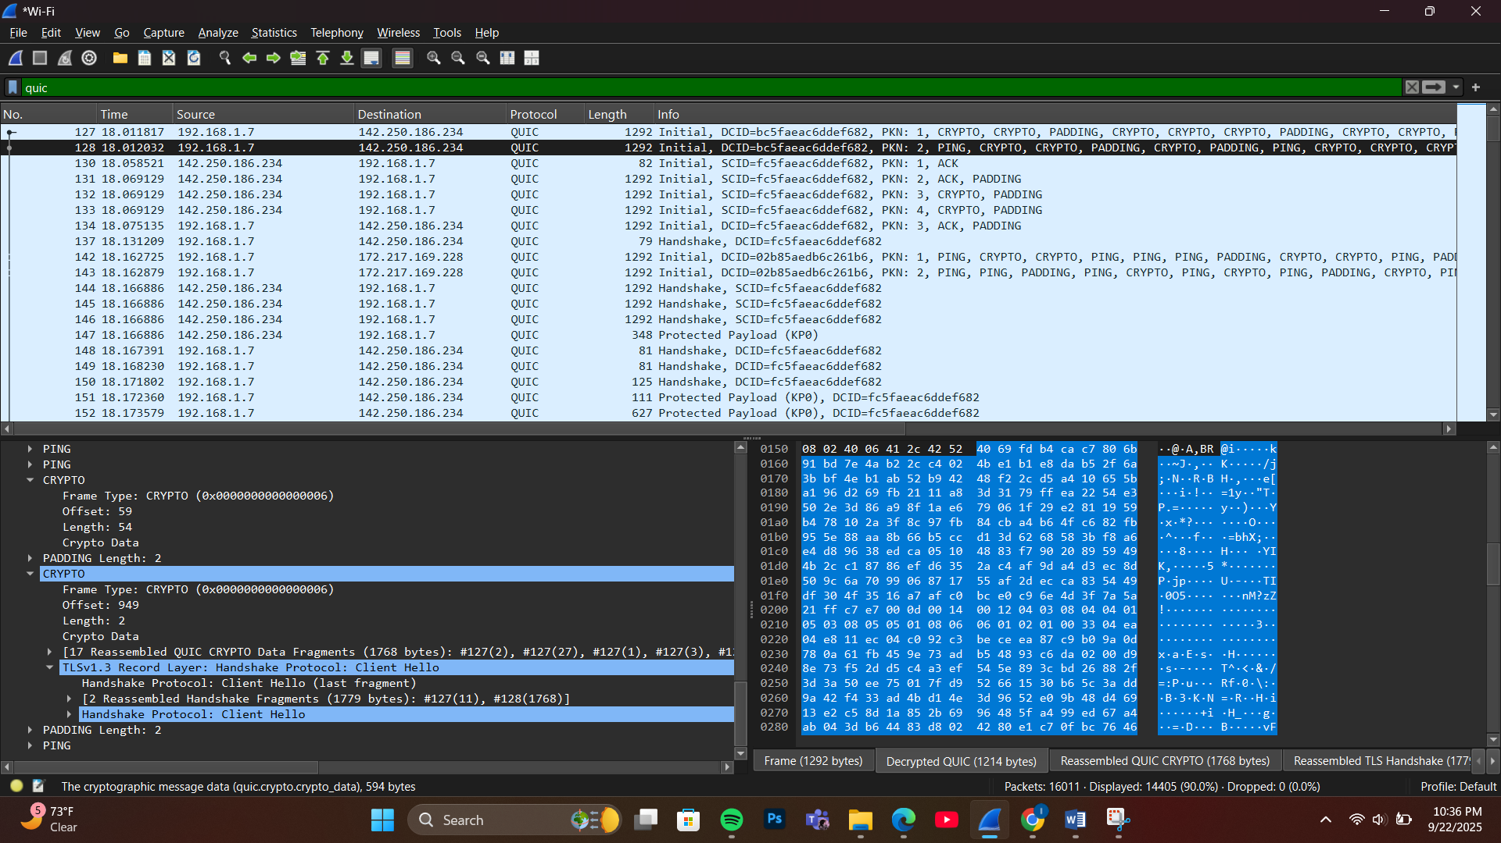

- QUIC Version Analysis:
• Check Version field: In QUIC header, note the version being used
• Compare: Note differences from traditional TCP-based connections

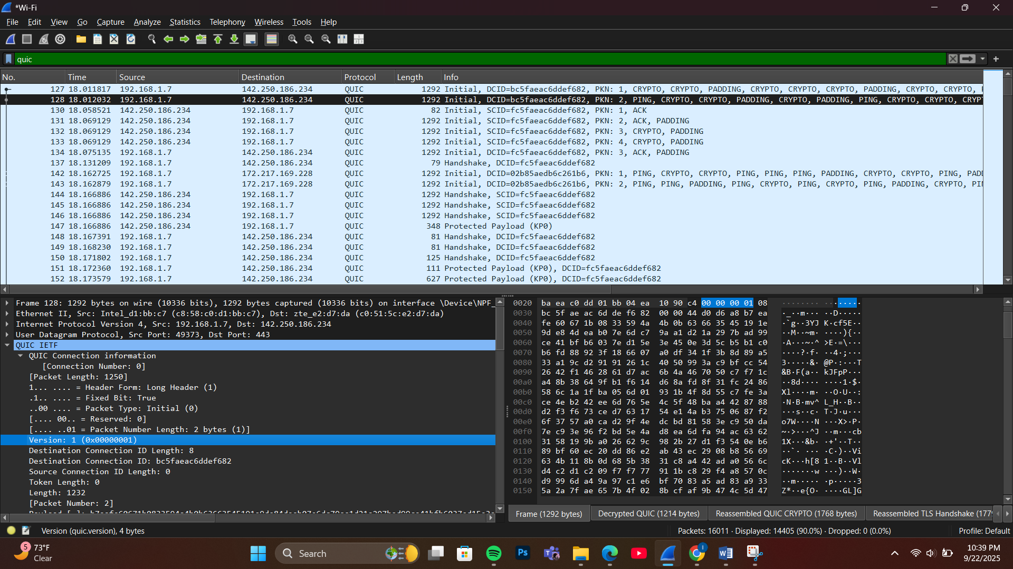

Version Found: QUIC Version 1 (0x00000001)
- This is the standardized QUIC version defined in RFC 9000
- Represents the first official release of QUIC protocol
Key Differences from Traditional TCP-based Connections:
Transport Protocol:
- QUIC: Built on UDP (User Datagram Protocol)
- TCP: Uses Transmission Control Protocol
Connection Establishment:
- QUIC: 0-RTT or 1-RTT connection establishment (faster)
- TCP: Requires 3-way handshake + separate TLS handshake (slower)
Security Integration:
- QUIC: TLS 1.3 built into the protocol (mandatory encryption)
- TCP: TLS is a separate layer on top of TCP
Stream Multiplexing:
- QUIC: Native multiplexing with independent streams (no head-of-line blocking)
- TCP: Single byte stream (head-of-line blocking affects all data)
Connection Migration:
- QUIC: Supports seamless connection migration across network changes
- TCP: Connection breaks when IP address or port changes
Congestion Control:
- QUIC: Modern congestion control algorithms built-in
- TCP: Legacy congestion control mechanisms
Evidence: Screenshot shows "Version: 1 (0x00000001)" in QUIC connection information, confirming use of standardized QUIC v1 protocol.
This analysis shows how QUIC represents a modern evolution beyond traditional TCP-based connections, offering improved performance and built-in security.

5. 0-RTT vs 1-RTT Analysis
- Examine packet flow: Check if 0-RTT data is present
- Determine: Whether connection uses 0-RTT or 1-RTT establishment
0-RTT vs 1-RTT Analysis:
Connection Type: 1-RTT establishment
Evidence:
- Initial packets followed by Handshake packets
- Protected Payload (application data) appears after handshake completion
- No early data transmission observed
- Full cryptographic handshake completed before data exchange

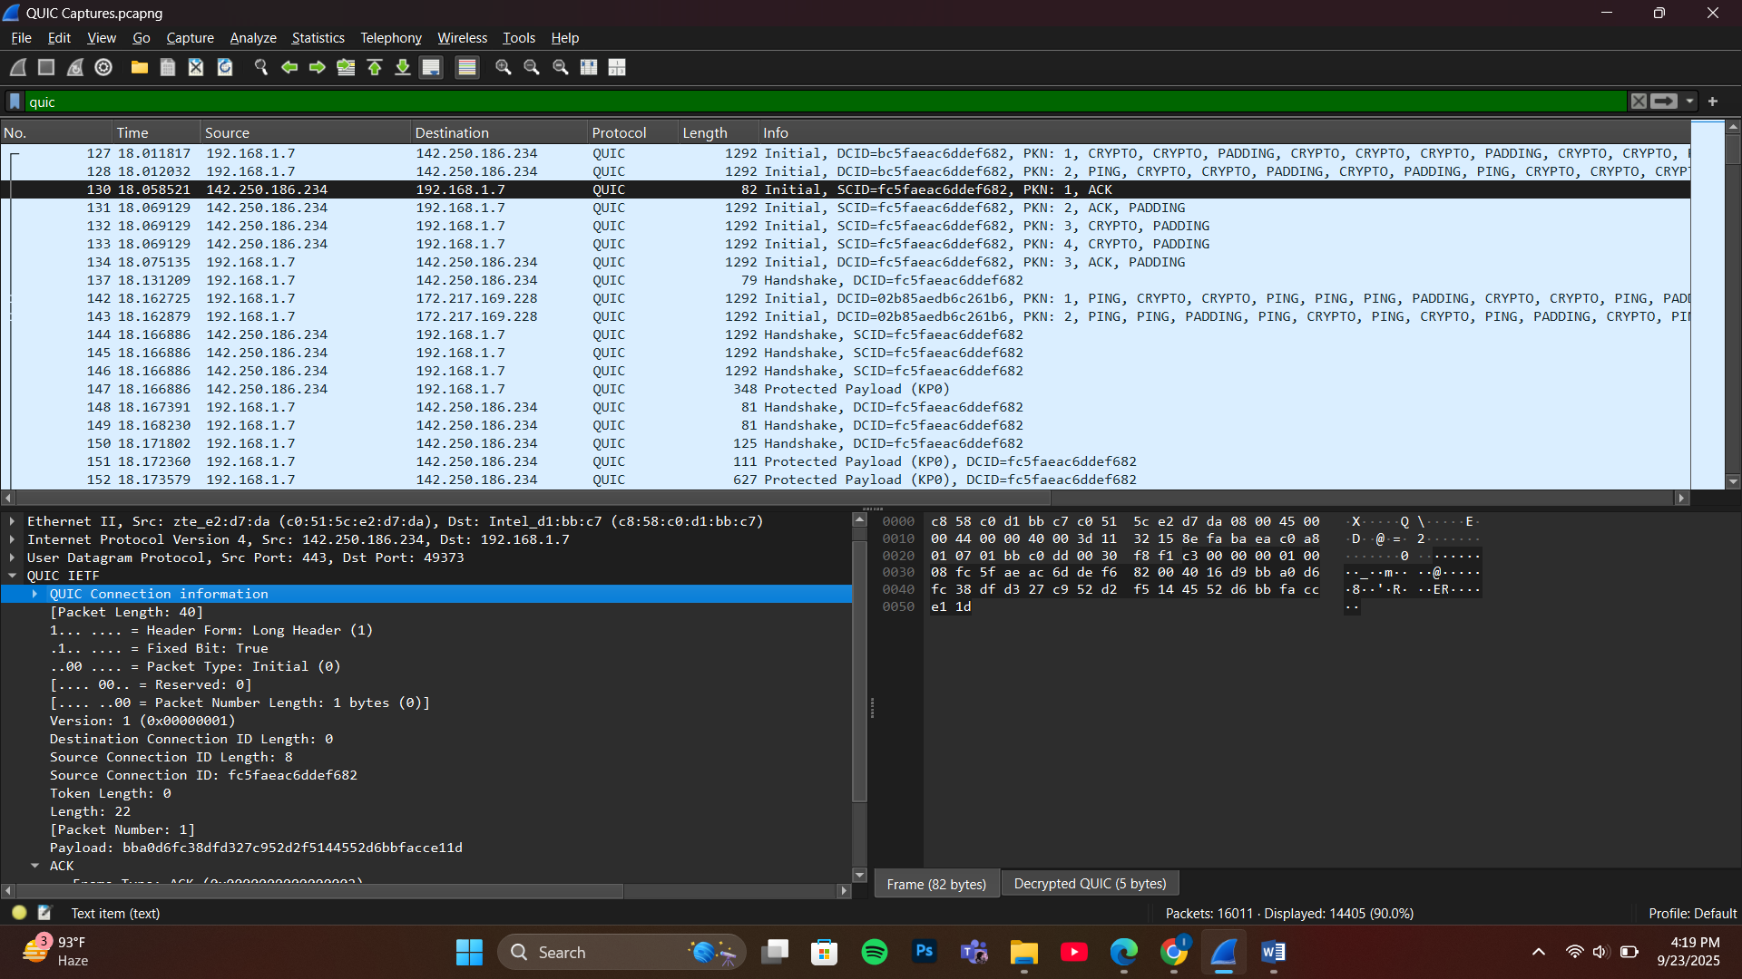

6. HTTP/3 vs HTTP/2 Comparison
- Analyze differences: Compare QUIC-based HTTP/3 with TCP-based HTTP/2
- Note differences: Connection establishment, multiplexing, packet structure
HTTP/3 vs HTTP/2 Comparison:

Connection Establishment:
- HTTP/3: QUIC 0-RTT/1-RTT handshake (faster)
- HTTP/2: TCP 3-way + TLS handshake (slower)

Multiplexing:
- HTTP/3: Independent QUIC streams, no head-of-line blocking
- HTTP/2: TCP-level head-of-line blocking affects all streams

Packet Structure:
- HTTP/3: QUIC frames containing HTTP data
- HTTP/2: TCP segments containing HTTP/2 frames

Transport Protocol:
- HTTP/3: UDP-based QUIC
- HTTP/2: TCP-based

Security:
- HTTP/3: Mandatory built-in TLS 1.3
- HTTP/2: Optional TLS layer

Evidence from Capture:
- QUIC protocol visible in packet list
- UDP port 443 usage
- CRYPTO frames containing TLS data
- Stream multiplexing within single QUIC connection

